|  |
| --- |
| Circle Language Spec: Execution Control |

## Exit Command in a Diagram

The concept of exit command is already covered by the article *Exit Command*. This article only explains its expression in a diagram.

Exit Command is defined in a command definition. It will transfer control to the command, that immediately follows after it. The Exit Command command is passed the Command End as an argument:

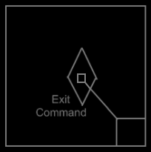

For information about the command end, see the article *Normal Execution Order* *in a Diagram*.

The normal execution order in the command *definition* is not yet pointing to the next step. It represents the normal execution order as it *will be* in a call to the command definition.

The Exit Command looks as follows inside a command call:

